TopCoder Cockpit - Marathon Match Contest Detail Page Version 1.0 Deployment Guide

Revision History
Author | Revision Number | Date
TCSASSEMBLER | 1.0 | 3/31/2013

Deployment Instructions 3
1. Organization of Submission 3
2. Application Setup 3
2.1 Configuration file setup 3
2.2 Build scripts setup 3
3. Database Setup 4
4. Deployment Instructions 4
5. Starting 4
6. Verification 4
7. Resource Contact List 18

Deployment Instructions

Organization of Submission

The submission has following directory structure:

doc

Contains this document which is the Deployment Guide this assembly.

direct

Contains all the updated and newly added sources files, static files and configuration files for the topcoder direct application and dependency components

svn_info.txt
The notes for reviewer, it lists the svn revisions used for this submission

testfiles

SQL script to insert some test data and help testing

Application Setup

The application is expected to be deployed to the following environment:

JRE 1.5
JBoss 4.2.3.GA
Informix DS 11.0

Configuration file setup

Configuration File | Description | Changes
conf/phase_templates/  TCSTemplate_Marathon_Match.xml | The phase template for marathon contest | Remove the review phase, the marathon contest only contains registration phase and submission phase now
conf/contestFees.xml | Contest fees configuration for different contest types | Remove the marathon contest fee configuration from the software group. There is existing config for it in the studio group.

Build scripts setup
The build script for Direct application (build.xml) provides the following targets which are to be used:

- switch-and-checkout –checkout or switch to the defined source code branches for all components defined in subprojects.xml
- dist-backend –rebuilt all the components from the source code.
- first_deploy –must be the first task to execute from command line. It will copy all dependencies to your local JBoss folder.
- deploy –should be the main task to execute from command line. It will build and deploy WAR file.
- deploy-apache-static –deploys the static files to jboss.

You can get more information here:
http://www.topcoder.com/wiki/display/docs/TC+Direct+Setup+Guide

Database Setup
- Insert test data on VM
  - Run testfiles\insert_problem_statements.sql
  - Run testfiles\insert_copilots.sql

Deployment Instructions

This section provides the instructions in Production environment.

- Go to the direct directory, run “ant switch-and-checkout” to update the backend first
- Update the direct trunk to the specified revision in svn_info.txt
- Update the project management persistence component to the specified revision in svn_info.txt
- Update the project service component to the specified revision in svn_info.txt
- Merge the code from direct directory into SVN for Direct application, it will also merge the project management persistence component
- Run “ant dist-backend” to rebuild all the back end components
- Build and deploy Direct application using ant deploy (or ant first_deploy ) command.
- Copy static files using ant deploy-apache-static command. If you on local machine, you need to use “ant deploy-static-files”

Starting

- Build and deploy the Direct application
- Start JBoss server instance hosting Direct application

Verification

After deploy and the JBOSS is successfully started. Log in into the Cockpit via the page http://cockpit.cloud.topcoder.com/direct/ with heffan / password

Go to the launch new contest page, clicking “Add New” to add a new project first

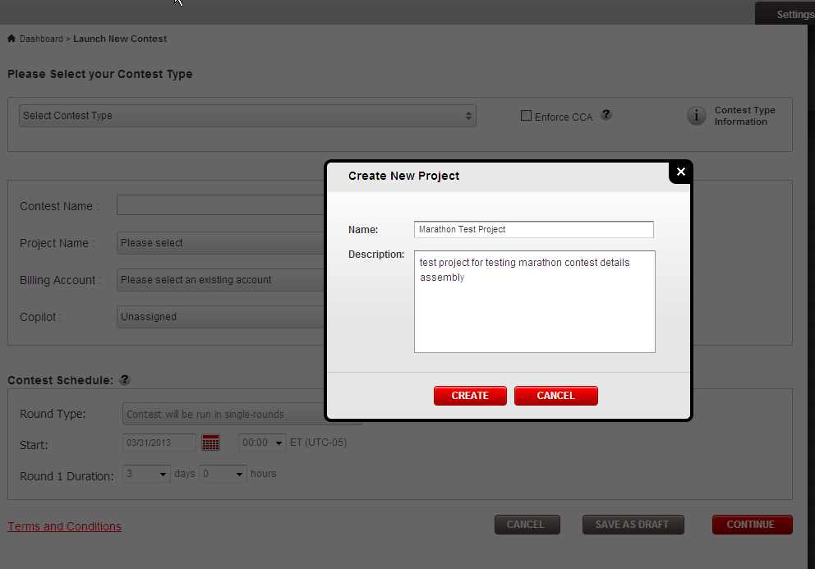

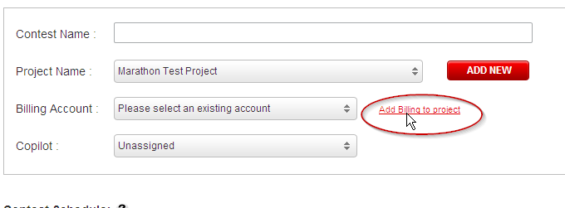

Clicking “Add Billing to project” to associate a billing account for this project

Add “Test Project 1” billing account to the project

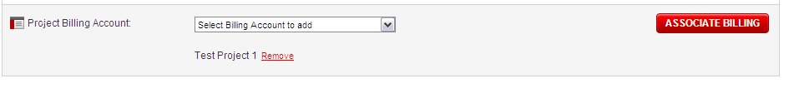
Go to project overview page and add copilot to this project

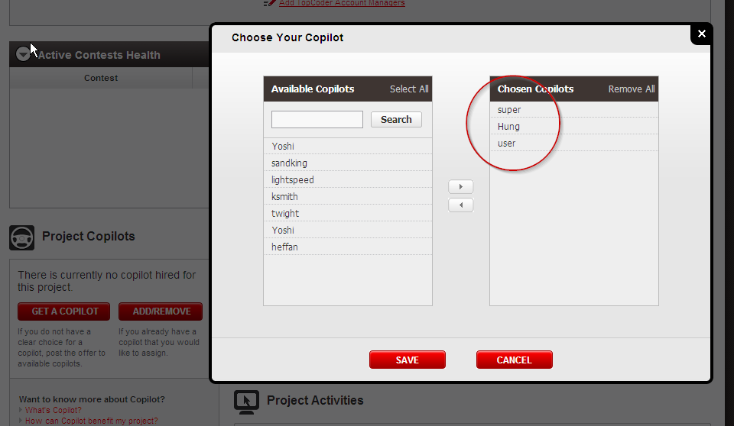

Refresh the “Launch New Contest” page

Add enter data to create a new marathon contest

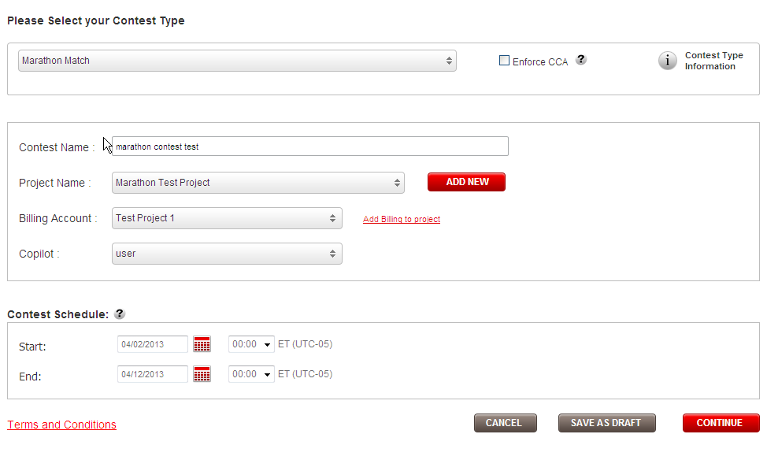

Clicking “CONTINUE” button to choose problem statement, match details, match rules

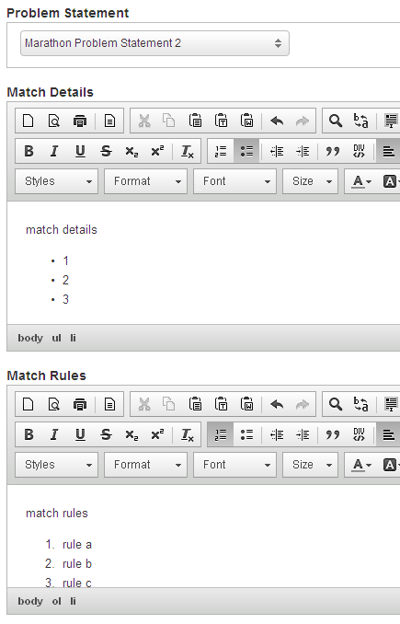

And fill prizes

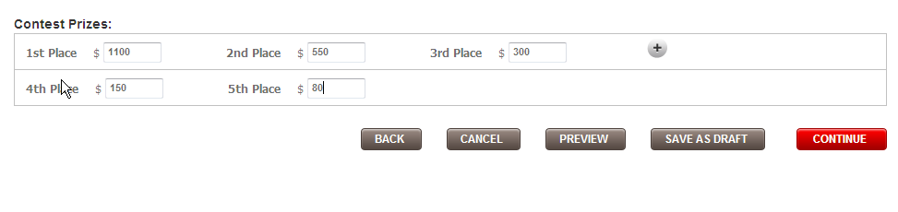

Clicking “Save as Draft” and wait the confirmation shown.

Then clicking View Contest to view the marathon contest details page

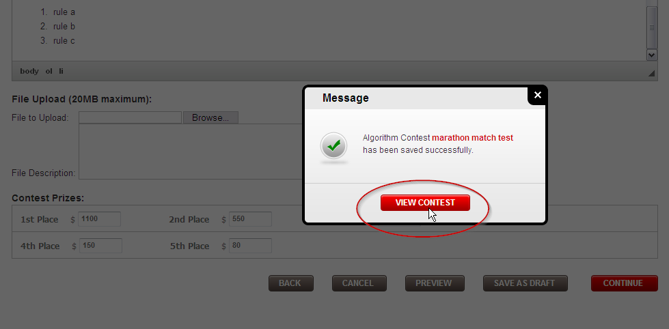

In the contest details page, you can see

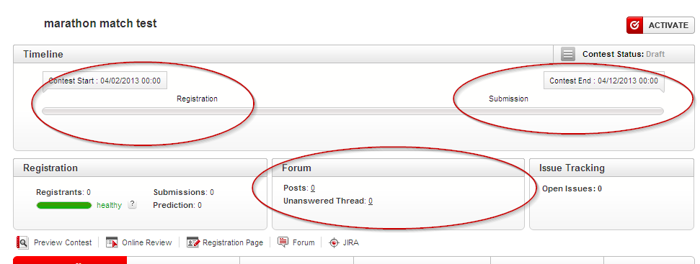

In contest dashboard, the review box is not shown because the marathon contest does not have reviewers.

The contest only has registration and submission phase and both of them are set to start at contest start date and ends at contest end date.

Check the contest details

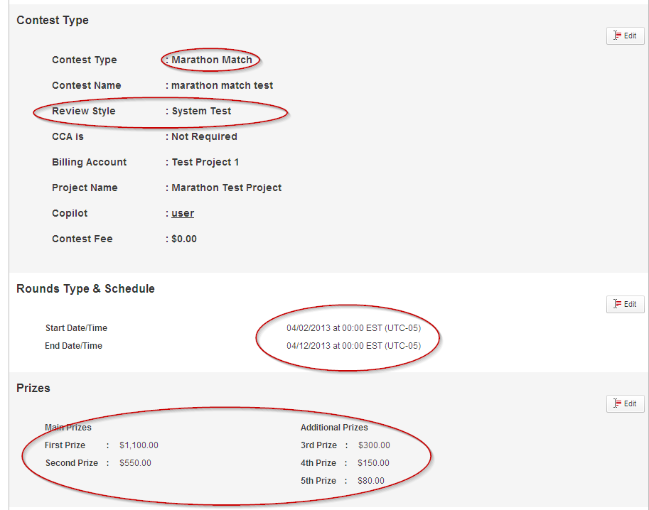
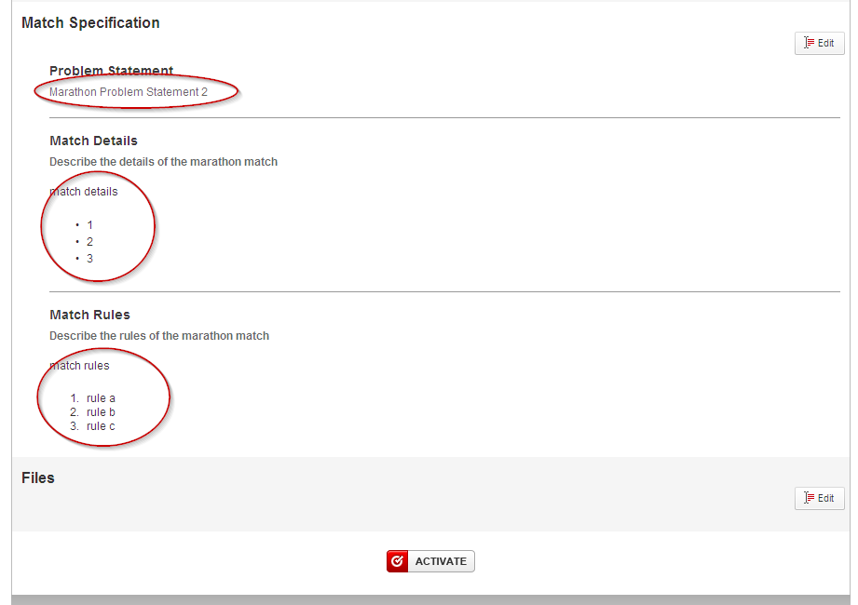

- The contest type is marathon match
- The review style is System Test
- The start / end date is displayed
- The prizes are listed
- The problem statement name is displayed
- The match details is displayed
- The match rules is displayed

Edit each section to test the edit and save

- Edit Contest Type section

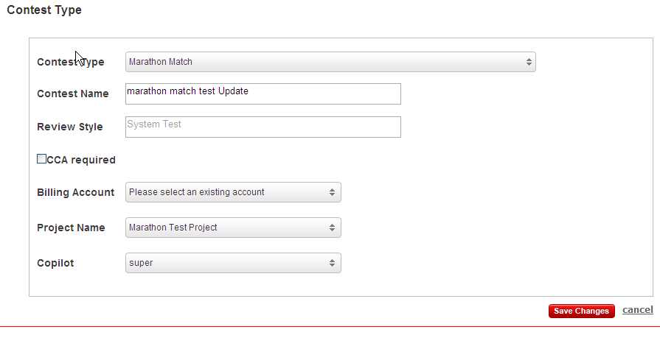

Update the name, billing account and copilot and clicking save

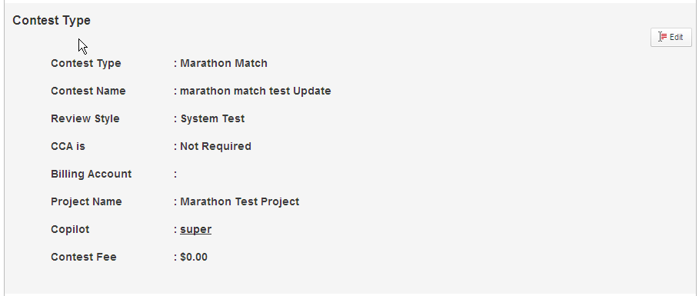

- Edit Schedule

Edit the start and end date/time to make the end date less than the start date

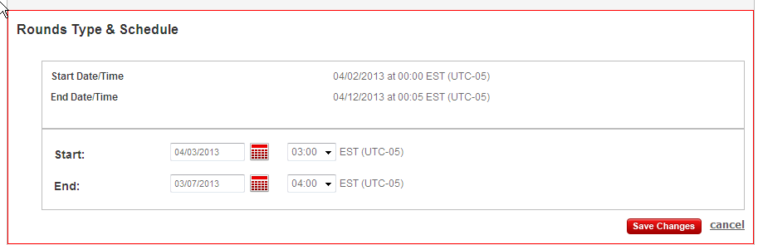

Click the Save Changes and you will see validation messages

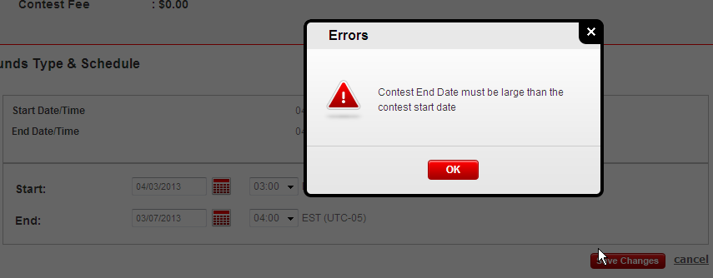

Change to correct end date and clicking Save again

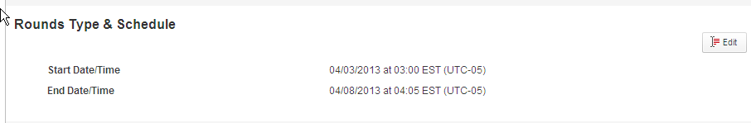

- Edit Prizes

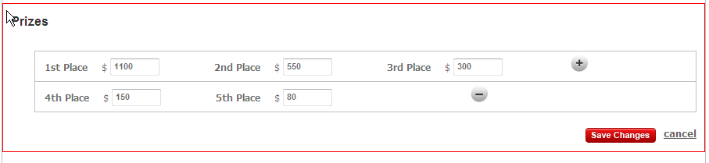
Edit the prizes

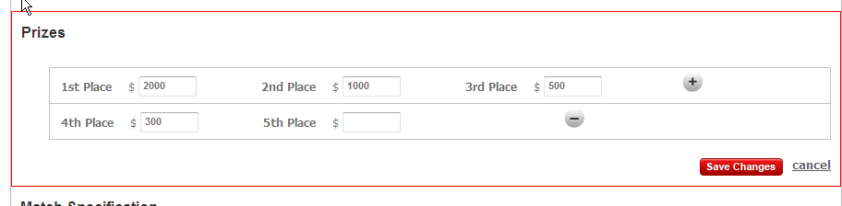

Clicks “Save Changes”

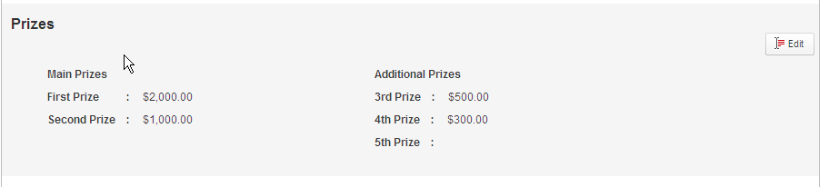

- Edit Marathon Problem Specification

Clicking Edit button

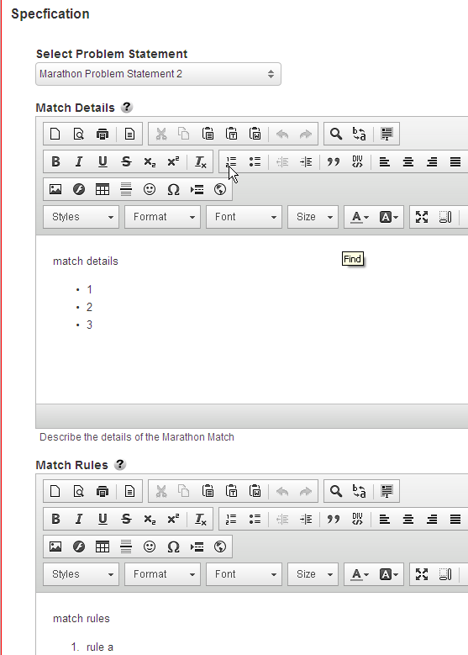

First clear the problem statement, match details and match rules then click Save

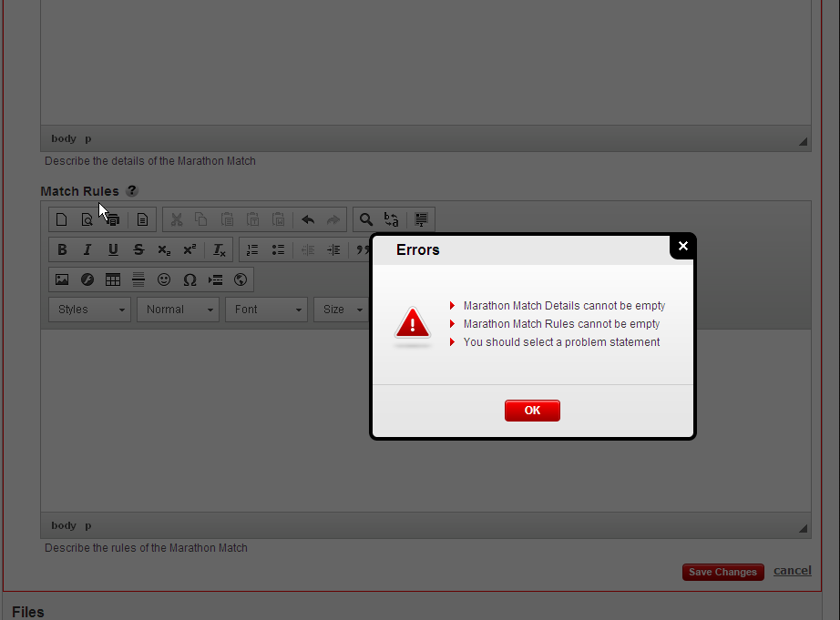

Validation errors are shown

Choose another problem statement, enter different match details, match rules and click Save

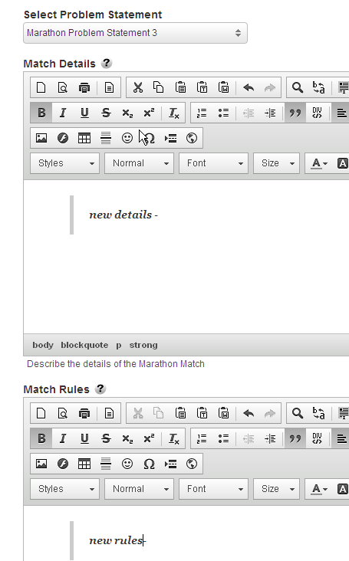

Clicking Save button

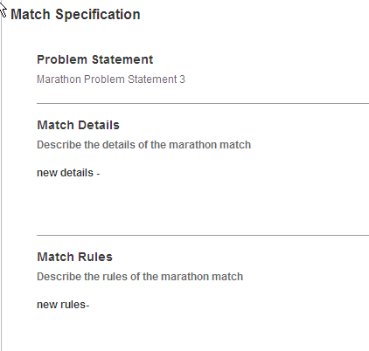

- Test upload files
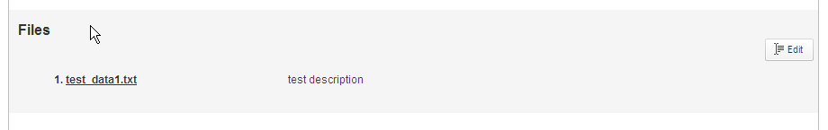

Choose a billing account and test activation

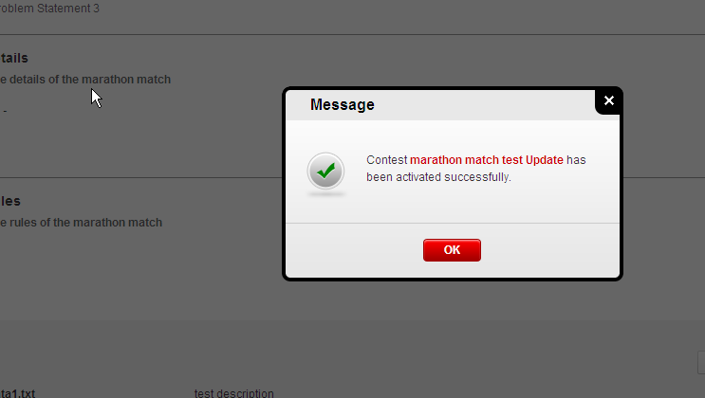

Resource Contact List

Name | Resource Email
TCSASSEMBLER

